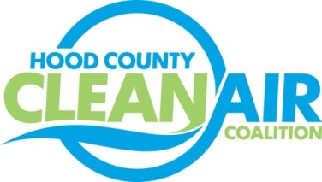
Meeting: Wednesday, June 1, 2016
Neely House
304 East Rucker Street, Granbury, Texas 76048
8:30-10:00 a.m.

Agenda

- Call Meeting to Order
- EPA Updates – Randy Pitre
- Regional Updates – Michelle McKenzie
  - Free Solar Webinars and Trainings Available (Information at http://www.gosolartexas.org/events/index.html)
    - Webinars on Friday - June 3, Friday - July 8, Wednesday - July 27
    - Training at NCTCOG Offices June 7-8 for Solar for Real Estate Professionals, Financing Solar, Fire Inspector and Fire Code Compliance, and Solar for Local Governments
  - Solar Designation Program for Cities (Details at http://www.gosparc.org/home-2/; Application Link at http://www.gosparc.org/apply-now)
  - Upcoming Fleet Opportunity – Cooperative Vehicle Procurement for Alternative Fuel and Advanced Technology Fleet Vehicles
  - Air Quality Funding Opportunities for Vehicles
  - Clean Air Action Day - June 24, 2016- Webinar Will Be Held to Honor the Day Commitments Can Be Logged at: http://airnorthtexas.org/cleanair.asp
- Local Updates – Michelle McKenzie
  - Review of May Meeting Summary
  - Review of Projects
    - Monthly Budget Review for April
    - Status of Projects FY 16/17
  - Reports
    - May Ozone Update
    - Air North Texas Meeting
  - 2016 Hood County Update for Ozone Advance
  - Annual Minutes filing for HCCAC
  - Community Appreciation Day in September
5.) USDA Presentation on REAP Program – Rose Gonzalez
6.) Discussion
7.) Adjourn

